CLEARANCE DOCUMENT - payment abroad number: 7770/191

Payer:
ABCD, s.r.o.
By Order of:

Paid the amount, currency:
2 256,00 EUR

Paid Amount, Currency:

Payee:
EFGH, s.r.o.
Beneficiary Address and Country:

Account number of the payee / IBAN:
1251001256
Beneficiary Acc, No:

Payee’s bank, address:
VÚB, Bratislava, Slovak Republic
Beneficiary Bank:

Swift:
CEKOSKBX

120-IMPORT OF GOODS
7700031745

SHA

7770191

16.9.2013
Payment title:
Payment title:

Reason for payment:
Payment reason:

Foreign bank charges:
Details of Charges:

Related confirmation:

Date of executing payment:
Due date:

Date and place of clearance: Prague, 16.9.2013
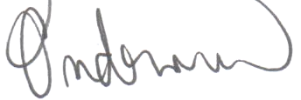

Ing. Barbora Ondrová
CYRRUS FX, a.s.

